***Phone Book***



**Stamford University Bangladesh**

**Project Report**

### Course Code: CSI-233

### Course Title: Advance Programming Sessional

**Submitted To**

**Md. Touhid Bin Iqbal, Ph.D.**

**Assistant Professor Department Of CSE, SUB**

**Submitted By:**

### Mahfuz rahman CSE06407577

### Sydul islam CSE 06507551

### MD. Ibrahim somir CSE 064 07522

# *ABSTRACT*

In our daily life, we used Phone Book for different reasons. There are also different units to measure Phone Book.

Phone Book is a very useful application . The feature of this simple application includes adding, updating, deleting, viewing and searching a list of telephone subscribers/members.

This document will discuss and create and implement in this application.

***TABLE OF CONTENTS***

ABSTRACT 2

1.0 INTRODUCTION 4

* 1. OVERALL DESCRIPTION… 5-6
  2. MAIN FEATURES 5
  3. ADVANTAGES 6
  4. DISADVANTAGES 6

3.0 SNAPSHOT OF APPLICATION 7-10

4.0 FLOW CHART OF PROJECT 11

5.0 PROJECT SOURCE CODE 12-38

* 1. CONCLUSION 39
  2. LIMATIONS AND FUTURE WORK… 39

***1.0 Introduction***

Phone Book is a very basic application the Swing toolkit in using graphical components in Java with MySQL as a data source. The feature of this simple application includes add, updating, delete,. modify and update according to need, search and remove unwanted data from the database and view , search a list of telephone subscribers/members.

In this project a user can Phone Book . It will help to save users time and do their work easily. It is easy to use and very user friendly. The application architecture is easy to handle and understandable. So, it will help the user .

# *OVERALL DESCRIPTION*

Phone Book application works dynamically. It has some features.

It’s a GUI-based java application.

## *Main Features:*

The main Features of the application are:

***Input data:***

A user can insert data that was ,name ,phone number ,city which user want to save. It inserts into a text field.

***Display:***

A user can see their name ,city, phone number is showing

In display from the database.

***Search:***

This field is to search the user of phone book .they can search their name, phone number ,city.

***Delete:***

A user can delete their record .

***Backup and print:***

A user can easily find their backup data that was ,name ,phone number ,city and print easily.

## *Advantages:*

* + - User Friendly
    - Easy to use and understandable
    - Less Complexity
    - Take less memory

## *Disadvantages:*

* + - Cannot store data through internet
    - Cannot delete one by one.

***3.0 SNAPSHOT OF APPLICATION:***

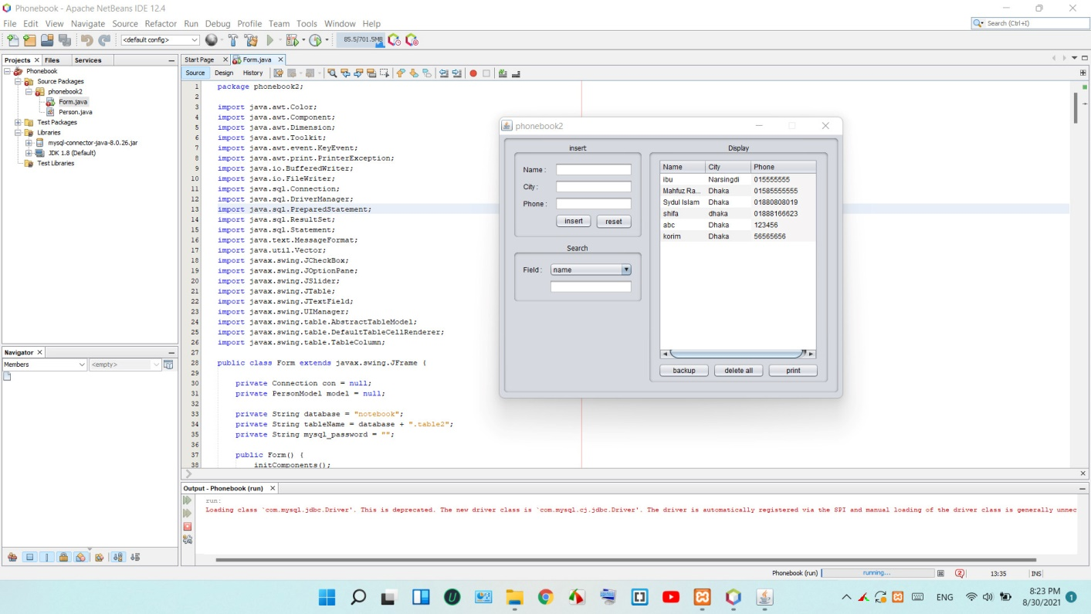

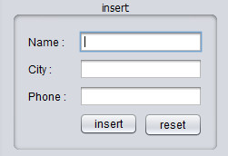

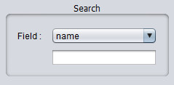

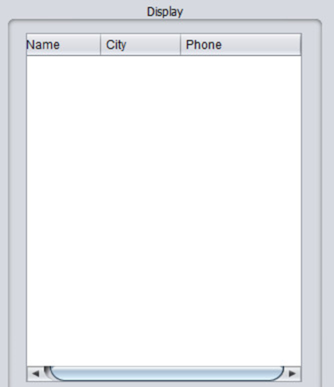

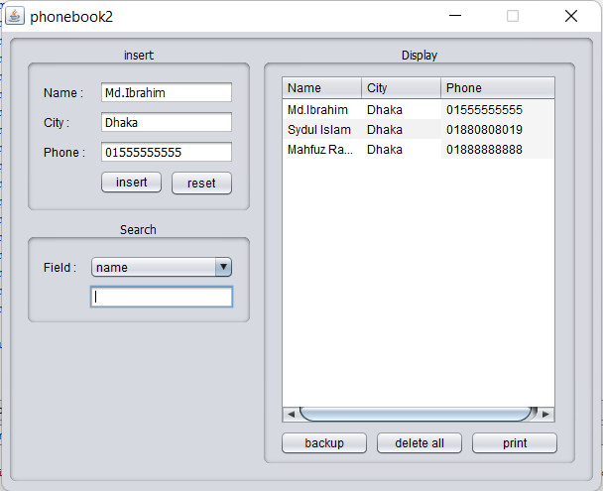

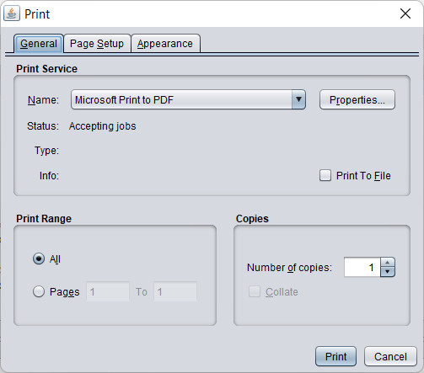



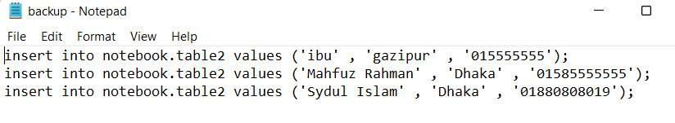

***4.0******Flow Chart of our project***

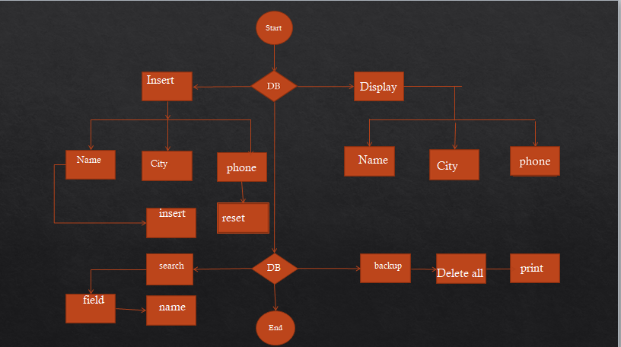

***5.0 PROJECT SOURCE CODE:***

package phonebook2;

import java.awt.Color;

import java.awt.Component;

import java.awt.Dimension;

import java.awt.Toolkit;

import java.awt.event.KeyEvent;

import java.awt.print.PrinterException;

import java.io.BufferedWriter;

import java.io.FileWriter;

import java.sql.Connection;

import java.sql.DriverManager;

import java.sql.PreparedStatement;

import java.sql.ResultSet;

import java.sql.Statement;

import java.text.MessageFormat;

import java.util.Vector;

import javax.swing.JCheckBox;

import javax.swing.JOptionPane;

import javax.swing.JSlider;

import javax.swing.JTable;

import javax.swing.JTextField;

import javax.swing.UIManager;

import javax.swing.table.AbstractTableModel;

import javax.swing.table.DefaultTableCellRenderer;

import javax.swing.table.TableColumn;

public class Form extends javax.swing.JFrame {

private Connection con = null;

private PersonModel model = null;

private String database = "notebook";

private String tableName = database + ".table2";

private String mysql_password = "";

public Form() {

initComponents();

Dimension d = Toolkit.getDefaultToolkit().getScreenSize();

int x = d.width/2 - this.getWidth()/2,

y = d.height/2 - this.getHeight()/2;

setLocation(x, y);

scrollPane.getViewport().setBackground(Color.WHITE);

}

@SuppressWarnings("unchecked")

// <editor-fold defaultstate="collapsed" desc="Generated Code">

private void initComponents() {

mainPanel = new javax.swing.JPanel();

infoPanel = new javax.swing.JPanel();

label1 = new javax.swing.JLabel();

Name = new javax.swing.JTextField();

City = new javax.swing.JTextField();

Phone = new javax.swing.JTextField();

label2 = new javax.swing.JLabel();

label3 = new javax.swing.JLabel();

Insert = new javax.swing.JButton();

Reset = new javax.swing.JButton();

searchPanel = new javax.swing.JPanel();

label4 = new javax.swing.JLabel();

fieldName = new javax.swing.JComboBox();

value = new javax.swing.JTextField();

tablePanel = new javax.swing.JPanel();

scrollPane = new javax.swing.JScrollPane();

dataTable = new javax.swing.JTable();

Backup = new javax.swing.JButton();

DeleteAll = new javax.swing.JButton();

Print = new javax.swing.JButton();

setDefaultCloseOperation(javax.swing.WindowConstants.EXIT_ON_CLOSE);

setTitle("phonebook2");

setResizable(false);

addWindowListener(new java.awt.event.WindowAdapter() {

public void windowOpened(java.awt.event.WindowEvent evt) {

formWindowOpened(evt);

}

});

mainPanel.setBorder(javax.swing.BorderFactory.createTitledBorder(null, "", javax.swing.border.TitledBorder.DEFAULT_JUSTIFICATION, javax.swing.border.TitledBorder.DEFAULT_POSITION, new java.awt.Font("Arial", 0, 12))); // NOI18N

infoPanel.setBorder(javax.swing.BorderFactory.createTitledBorder(null, "insert", javax.swing.border.TitledBorder.CENTER, javax.swing.border.TitledBorder.DEFAULT_POSITION, new java.awt.Font("Tahoma", 0, 12))); // NOI18N

label1.setFont(new java.awt.Font("Arial", 0, 12)); // NOI18N

label1.setText("Name :");

Name.setFont(new java.awt.Font("Tahoma", 0, 12)); // NOI18N

City.setFont(new java.awt.Font("Tahoma", 0, 12)); // NOI18N

Phone.setFont(new java.awt.Font("Tahoma", 0, 12)); // NOI18N

label2.setFont(new java.awt.Font("Arial", 0, 12)); // NOI18N

label2.setText("Phone :");

label3.setFont(new java.awt.Font("Arial", 0, 12)); // NOI18N

label3.setText("City :");

Insert.setFont(new java.awt.Font("Arial", 0, 12)); // NOI18N

Insert.setText("insert");

Insert.addActionListener(new java.awt.event.ActionListener() {

public void actionPerformed(java.awt.event.ActionEvent evt) {

InsertActionPerformed(evt);

}

});

Reset.setFont(new java.awt.Font("Arial", 0, 12)); // NOI18N

Reset.setText("reset");

Reset.setNextFocusableComponent(fieldName);

Reset.addActionListener(new java.awt.event.ActionListener() {

public void actionPerformed(java.awt.event.ActionEvent evt) {

ResetActionPerformed(evt);

}

});

javax.swing.GroupLayout infoPanelLayout = new javax.swing.GroupLayout(infoPanel);

infoPanel.setLayout(infoPanelLayout);

infoPanelLayout.setHorizontalGroup(

infoPanelLayout.createParallelGroup(javax.swing.GroupLayout.Alignment.LEADING)

.addGroup(infoPanelLayout.createSequentialGroup()

.addContainerGap()

.addGroup(infoPanelLayout.createParallelGroup(javax.swing.GroupLayout.Alignment.LEADING, false)

.addGroup(infoPanelLayout.createSequentialGroup()

.addComponent(label1, javax.swing.GroupLayout.PREFERRED_SIZE, 50, javax.swing.GroupLayout.PREFERRED_SIZE)

.addPreferredGap(javax.swing.LayoutStyle.ComponentPlacement.RELATED)

.addComponent(Name))

.addGroup(infoPanelLayout.createSequentialGroup()

.addComponent(label3, javax.swing.GroupLayout.PREFERRED_SIZE, 50, javax.swing.GroupLayout.PREFERRED_SIZE)

.addPreferredGap(javax.swing.LayoutStyle.ComponentPlacement.RELATED)

.addComponent(City))

.addGroup(infoPanelLayout.createSequentialGroup()

.addComponent(label2, javax.swing.GroupLayout.PREFERRED_SIZE, 50, javax.swing.GroupLayout.PREFERRED_SIZE)

.addPreferredGap(javax.swing.LayoutStyle.ComponentPlacement.RELATED)

.addGroup(infoPanelLayout.createParallelGroup(javax.swing.GroupLayout.Alignment.LEADING, false)

.addGroup(infoPanelLayout.createSequentialGroup()

.addComponent(Insert, javax.swing.GroupLayout.PREFERRED_SIZE, 65, javax.swing.GroupLayout.PREFERRED_SIZE)

.addPreferredGap(javax.swing.LayoutStyle.ComponentPlacement.RELATED)

.addComponent(Reset, javax.swing.GroupLayout.PREFERRED_SIZE, 65, javax.swing.GroupLayout.PREFERRED_SIZE))

.addComponent(Phone))))

.addContainerGap(javax.swing.GroupLayout.DEFAULT_SIZE, Short.MAX_VALUE))

);

infoPanelLayout.setVerticalGroup(

infoPanelLayout.createParallelGroup(javax.swing.GroupLayout.Alignment.LEADING)

.addGroup(infoPanelLayout.createSequentialGroup()

.addContainerGap()

.addGroup(infoPanelLayout.createParallelGroup(javax.swing.GroupLayout.Alignment.BASELINE)

.addComponent(label1)

.addComponent(Name, javax.swing.GroupLayout.PREFERRED_SIZE, 24, javax.swing.GroupLayout.PREFERRED_SIZE))

.addPreferredGap(javax.swing.LayoutStyle.ComponentPlacement.RELATED)

.addGroup(infoPanelLayout.createParallelGroup(javax.swing.GroupLayout.Alignment.BASELINE)

.addComponent(label3)

.addComponent(City, javax.swing.GroupLayout.PREFERRED_SIZE, 24, javax.swing.GroupLayout.PREFERRED_SIZE))

.addPreferredGap(javax.swing.LayoutStyle.ComponentPlacement.RELATED)

.addGroup(infoPanelLayout.createParallelGroup(javax.swing.GroupLayout.Alignment.BASELINE)

.addComponent(label2)

.addComponent(Phone, javax.swing.GroupLayout.PREFERRED_SIZE, 24, javax.swing.GroupLayout.PREFERRED_SIZE))

.addPreferredGap(javax.swing.LayoutStyle.ComponentPlacement.RELATED)

.addGroup(infoPanelLayout.createParallelGroup(javax.swing.GroupLayout.Alignment.LEADING, false)

.addComponent(Reset, javax.swing.GroupLayout.DEFAULT_SIZE, javax.swing.GroupLayout.DEFAULT_SIZE, Short.MAX_VALUE)

.addComponent(Insert, javax.swing.GroupLayout.PREFERRED_SIZE, 25, javax.swing.GroupLayout.PREFERRED_SIZE))

.addContainerGap(javax.swing.GroupLayout.DEFAULT_SIZE, Short.MAX_VALUE))

);

searchPanel.setBorder(javax.swing.BorderFactory.createTitledBorder(null, "Search", javax.swing.border.TitledBorder.CENTER, javax.swing.border.TitledBorder.DEFAULT_POSITION, new java.awt.Font("Tahoma", 0, 12))); // NOI18N

label4.setFont(new java.awt.Font("Arial", 0, 12)); // NOI18N

label4.setText("Field :");

fieldName.setFont(new java.awt.Font("Arial", 0, 12)); // NOI18N

fieldName.setModel(new javax.swing.DefaultComboBoxModel(new String[] { "name", "city", "phone" }));

fieldName.setNextFocusableComponent(value);

value.setFont(new java.awt.Font("Tahoma", 0, 12)); // NOI18N

value.addKeyListener(new java.awt.event.KeyAdapter() {

public void keyReleased(java.awt.event.KeyEvent evt) {

valueKeyReleased(evt);

}

});

javax.swing.GroupLayout searchPanelLayout = new javax.swing.GroupLayout(searchPanel);

searchPanel.setLayout(searchPanelLayout);

searchPanelLayout.setHorizontalGroup(

searchPanelLayout.createParallelGroup(javax.swing.GroupLayout.Alignment.LEADING)

.addGroup(searchPanelLayout.createSequentialGroup()

.addContainerGap()

.addComponent(label4, javax.swing.GroupLayout.PREFERRED_SIZE, 40, javax.swing.GroupLayout.PREFERRED_SIZE)

.addPreferredGap(javax.swing.LayoutStyle.ComponentPlacement.RELATED)

.addGroup(searchPanelLayout.createParallelGroup(javax.swing.GroupLayout.Alignment.LEADING)

.addComponent(value)

.addComponent(fieldName, 0, javax.swing.GroupLayout.DEFAULT_SIZE, Short.MAX_VALUE))

.addContainerGap())

);

searchPanelLayout.setVerticalGroup(

searchPanelLayout.createParallelGroup(javax.swing.GroupLayout.Alignment.LEADING)

.addGroup(searchPanelLayout.createSequentialGroup()

.addContainerGap()

.addGroup(searchPanelLayout.createParallelGroup(javax.swing.GroupLayout.Alignment.BASELINE)

.addComponent(label4)

.addComponent(fieldName, javax.swing.GroupLayout.PREFERRED_SIZE, 24, javax.swing.GroupLayout.PREFERRED_SIZE))

.addPreferredGap(javax.swing.LayoutStyle.ComponentPlacement.RELATED)

.addComponent(value, javax.swing.GroupLayout.PREFERRED_SIZE, 24, javax.swing.GroupLayout.PREFERRED_SIZE)

.addContainerGap(javax.swing.GroupLayout.DEFAULT_SIZE, Short.MAX_VALUE))

);

tablePanel.setBorder(javax.swing.BorderFactory.createTitledBorder(null, "Display", javax.swing.border.TitledBorder.CENTER, javax.swing.border.TitledBorder.DEFAULT_POSITION, new java.awt.Font("Tahoma", 0, 12))); // NOI18N

dataTable.setModel(new javax.swing.table.DefaultTableModel(

new Object [][] {

},

new String [] {

}

));

dataTable.setAutoResizeMode(javax.swing.JTable.AUTO_RESIZE_OFF);

dataTable.setGridColor(new java.awt.Color(204, 204, 204));

dataTable.setRowHeight(20);

dataTable.setSelectionBackground(new java.awt.Color(102, 182, 250));

dataTable.setSelectionMode(javax.swing.ListSelectionModel.SINGLE_SELECTION);

dataTable.getTableHeader().setReorderingAllowed(false);

dataTable.addKeyListener(new java.awt.event.KeyAdapter() {

public void keyReleased(java.awt.event.KeyEvent evt) {

dataTableKeyReleased(evt);

}

});

scrollPane.setViewportView(dataTable);

Backup.setFont(new java.awt.Font("Arial", 0, 12)); // NOI18N

Backup.setText("backup");

Backup.addActionListener(new java.awt.event.ActionListener() {

public void actionPerformed(java.awt.event.ActionEvent evt) {

BackupActionPerformed(evt);

}

});

DeleteAll.setFont(new java.awt.Font("Arial", 0, 12)); // NOI18N

DeleteAll.setText("delete all");

DeleteAll.addActionListener(new java.awt.event.ActionListener() {

public void actionPerformed(java.awt.event.ActionEvent evt) {

DeleteAllActionPerformed(evt);

}

});

Print.setFont(new java.awt.Font("Arial", 0, 12)); // NOI18N

Print.setText("print");

Print.addActionListener(new java.awt.event.ActionListener() {

public void actionPerformed(java.awt.event.ActionEvent evt) {

PrintActionPerformed(evt);

}

});

javax.swing.GroupLayout tablePanelLayout = new javax.swing.GroupLayout(tablePanel);

tablePanel.setLayout(tablePanelLayout);

tablePanelLayout.setHorizontalGroup(

tablePanelLayout.createParallelGroup(javax.swing.GroupLayout.Alignment.LEADING)

.addGroup(tablePanelLayout.createSequentialGroup()

.addContainerGap()

.addGroup(tablePanelLayout.createParallelGroup(javax.swing.GroupLayout.Alignment.LEADING)

.addComponent(scrollPane, javax.swing.GroupLayout.PREFERRED_SIZE, 280, javax.swing.GroupLayout.PREFERRED_SIZE)

.addGroup(tablePanelLayout.createSequentialGroup()

.addComponent(Backup, javax.swing.GroupLayout.PREFERRED_SIZE, 90, javax.swing.GroupLayout.PREFERRED_SIZE)

.addPreferredGap(javax.swing.LayoutStyle.ComponentPlacement.RELATED)

.addComponent(DeleteAll, javax.swing.GroupLayout.PREFERRED_SIZE, 90, javax.swing.GroupLayout.PREFERRED_SIZE)

.addPreferredGap(javax.swing.LayoutStyle.ComponentPlacement.RELATED)

.addComponent(Print, javax.swing.GroupLayout.PREFERRED_SIZE, 90, javax.swing.GroupLayout.PREFERRED_SIZE)))

.addContainerGap(javax.swing.GroupLayout.DEFAULT_SIZE, Short.MAX_VALUE))

);

tablePanelLayout.setVerticalGroup(

tablePanelLayout.createParallelGroup(javax.swing.GroupLayout.Alignment.LEADING)

.addGroup(tablePanelLayout.createSequentialGroup()

.addComponent(scrollPane, javax.swing.GroupLayout.PREFERRED_SIZE, 0, Short.MAX_VALUE)

.addPreferredGap(javax.swing.LayoutStyle.ComponentPlacement.RELATED)

.addGroup(tablePanelLayout.createParallelGroup(javax.swing.GroupLayout.Alignment.BASELINE)

.addComponent(Backup, javax.swing.GroupLayout.PREFERRED_SIZE, 25, javax.swing.GroupLayout.PREFERRED_SIZE)

.addComponent(DeleteAll, javax.swing.GroupLayout.PREFERRED_SIZE, 25, javax.swing.GroupLayout.PREFERRED_SIZE)

.addComponent(Print, javax.swing.GroupLayout.PREFERRED_SIZE, 25, javax.swing.GroupLayout.PREFERRED_SIZE)))

);

javax.swing.GroupLayout mainPanelLayout = new javax.swing.GroupLayout(mainPanel);

mainPanel.setLayout(mainPanelLayout);

mainPanelLayout.setHorizontalGroup(

mainPanelLayout.createParallelGroup(javax.swing.GroupLayout.Alignment.LEADING)

.addGroup(mainPanelLayout.createSequentialGroup()

.addContainerGap()

.addGroup(mainPanelLayout.createParallelGroup(javax.swing.GroupLayout.Alignment.LEADING, false)

.addComponent(infoPanel, javax.swing.GroupLayout.DEFAULT_SIZE, javax.swing.GroupLayout.DEFAULT_SIZE, Short.MAX_VALUE)

.addComponent(searchPanel, javax.swing.GroupLayout.DEFAULT_SIZE, javax.swing.GroupLayout.DEFAULT_SIZE, Short.MAX_VALUE))

.addPreferredGap(javax.swing.LayoutStyle.ComponentPlacement.RELATED)

.addComponent(tablePanel, javax.swing.GroupLayout.PREFERRED_SIZE, javax.swing.GroupLayout.DEFAULT_SIZE, javax.swing.GroupLayout.PREFERRED_SIZE)

.addContainerGap(javax.swing.GroupLayout.DEFAULT_SIZE, Short.MAX_VALUE))

);

mainPanelLayout.setVerticalGroup(

mainPanelLayout.createParallelGroup(javax.swing.GroupLayout.Alignment.LEADING)

.addGroup(mainPanelLayout.createSequentialGroup()

.addGroup(mainPanelLayout.createParallelGroup(javax.swing.GroupLayout.Alignment.TRAILING, false)

.addGroup(mainPanelLayout.createSequentialGroup()

.addComponent(infoPanel, javax.swing.GroupLayout.PREFERRED_SIZE, javax.swing.GroupLayout.DEFAULT_SIZE, javax.swing.GroupLayout.PREFERRED_SIZE)

.addPreferredGap(javax.swing.LayoutStyle.ComponentPlacement.RELATED)

.addComponent(searchPanel, javax.swing.GroupLayout.PREFERRED_SIZE, javax.swing.GroupLayout.DEFAULT_SIZE, javax.swing.GroupLayout.PREFERRED_SIZE)

.addGap(142, 142, 142))

.addComponent(tablePanel, javax.swing.GroupLayout.DEFAULT_SIZE, javax.swing.GroupLayout.DEFAULT_SIZE, Short.MAX_VALUE))

.addContainerGap(javax.swing.GroupLayout.DEFAULT_SIZE, Short.MAX_VALUE))

);

javax.swing.GroupLayout layout = new javax.swing.GroupLayout(getContentPane());

getContentPane().setLayout(layout);

layout.setHorizontalGroup(

layout.createParallelGroup(javax.swing.GroupLayout.Alignment.LEADING)

.addGroup(layout.createSequentialGroup()

.addContainerGap()

.addComponent(mainPanel, javax.swing.GroupLayout.PREFERRED_SIZE, javax.swing.GroupLayout.DEFAULT_SIZE, javax.swing.GroupLayout.PREFERRED_SIZE)

.addContainerGap(javax.swing.GroupLayout.DEFAULT_SIZE, Short.MAX_VALUE))

);

layout.setVerticalGroup(

layout.createParallelGroup(javax.swing.GroupLayout.Alignment.LEADING)

.addGroup(layout.createSequentialGroup()

.addContainerGap()

.addComponent(mainPanel, javax.swing.GroupLayout.PREFERRED_SIZE, javax.swing.GroupLayout.DEFAULT_SIZE, javax.swing.GroupLayout.PREFERRED_SIZE)

.addContainerGap(javax.swing.GroupLayout.DEFAULT_SIZE, Short.MAX_VALUE))

);

pack();

}// </editor-fold>

private void ResetActionPerformed(java.awt.event.ActionEvent evt) {

for(Component comp : this.infoPanel.getComponents())

if(comp instanceof JTextField)

((JTextField)comp).setText("");

}

private void formWindowOpened(java.awt.event.WindowEvent evt) {

try{

// found jdbc driver for mysql

Class.forName("com.mysql.jdbc.Driver");

// create connection to mysql

String url = "jdbc:mysql://localhost/",

uname = "root",

upass = mysql_password;

con = DriverManager.getConnection(url, uname, upass);

createDatabase();

createTable();

Vector data = getData("");

showData(data);

//set database

con.setCatalog(database);

}catch(Exception e){

JOptionPane.showMessageDialog(this, e.getMessage() + "\nCan not connected to mysql!");

this.dispose();

}

}

private void InsertActionPerformed(java.awt.event.ActionEvent evt) {

try{

if(isEmpty())

throw new Exception("please enter all data!");

// if phone is frequency dont insert

if(isExitsPhone())

throw new Exception("phone number is frequency!");

boolean ok = insert();

if(ok){

Vector data = getData("");

showData(data);

} else

throw new Exception("an error occure at inserting!");

}catch(Exception e){

JOptionPane.showMessageDialog(this, e.getMessage());

}

}

private void dataTableKeyReleased(java.awt.event.KeyEvent evt) {

if(evt.getKeyCode() != KeyEvent.VK_DELETE)

return;

JTable table = (JTable)evt.getSource();

int row = table.getSelectedRow();

if(row < 0)

return;

Object phone = table.getValueAt(row, 2);

if(cb_shwDlg.isSelected()){

int option = JOptionPane.showConfirmDialog(this, "Do you want to delete this item?",

"delete", JOptionPane.YES_NO_CANCEL_OPTION);

if(option != JOptionPane.YES_OPTION)

return;

}

try{

boolean ok = delete(phone);

if(ok){

Vector data = getData("");

showData(data);

} else

throw new Exception("an error occure at deleting!");

}catch(Exception e){

JOptionPane.showMessageDialog(this, e.getMessage());

}

}

private void valueKeyReleased(java.awt.event.KeyEvent evt) {

String text = value.getText().trim();

try{

String where = "";

if(!text.equals(""))

where = " WHERE " + fieldName.getSelectedItem() + " LIKE '" + text + "%'";

Vector data = getData(where);

showData(data);

}catch(Exception e){

}

}

private void PrintActionPerformed(java.awt.event.ActionEvent evt) {

MessageFormat headerFmt = new MessageFormat("Notebook"),

footerFmt = new MessageFormat("Page {0}");

JTable.PrintMode printMode = JTable.PrintMode.FIT_WIDTH;

try {

boolean status = dataTable.print(printMode, headerFmt, footerFmt);

if (status) {

JOptionPane.showMessageDialog(dataTable.getParent(), "printing is Complete",

"printing Result", JOptionPane.INFORMATION_MESSAGE);

} else {

JOptionPane.showMessageDialog(dataTable.getParent(), "printing Cancelled",

"printing Result",JOptionPane.INFORMATION_MESSAGE);

}

} catch (PrinterException pe) {

String errorMessage = MessageFormat.format("printing Failed", new Object[] {pe.getMessage()});

JOptionPane.showMessageDialog(dataTable.getParent(), errorMessage,

"printing Result", JOptionPane.ERROR_MESSAGE);

} catch (SecurityException se) {

String errorMessage = MessageFormat.format("printing Failed", new Object[] {se.getMessage()});

JOptionPane.showMessageDialog(dataTable.getParent(), errorMessage,

"TableDemo.printingResult", JOptionPane.ERROR_MESSAGE);

}

}

private void DeleteAllActionPerformed(java.awt.event.ActionEvent evt) {

try{

int row = deleteall();

Vector data = getData("");

showData(data);

throw new Exception(row + " row(s) deleted!");

}catch(Exception e){

JOptionPane.showMessageDialog(this, e.getMessage());

}

}

private void BackupActionPerformed(java.awt.event.ActionEvent evt) {

try{

BufferedWriter writer = new BufferedWriter(new FileWriter("backup.sql"));

Vector allData = getData("");

for(int row = 0; row < allData.size(); ++row){

Person data = (Person)allData.elementAt(row);

String sql = "insert into " + tableName + " values ('" + data.getName() + "' , '" +

data.getCity() + "' , '" + data.getPhone() + "');";

writer.write(sql);

writer.newLine();

}

writer.close();

JOptionPane.showMessageDialog(this, "successfull backupping!" , "backup", JOptionPane.INFORMATION_MESSAGE);

}catch(Exception e){

JOptionPane.showMessageDialog(this, "an error occure at backupping!" , "formWindowOpened", JOptionPane.ERROR_MESSAGE);

}

}

private boolean isEmpty(){

Component[] comps = infoPanel.getComponents();

for(int i = 0; i < comps.length; ++i){

Component comp = comps[i];

if(comp instanceof JTextField){

JTextField field = (JTextField)comp;

if(field.getText().equals(""))

return true;

}

}

return false;

}

private void createDatabase() throws Exception{

Statement stm = this.con.createStatement();

stm.execute("CREATE DATABASE IF NOT EXISTS " + database +

" DEFAULT CHARACTER SET utf8 COLLATE utf8_persian_ci");

}

private void createTable() throws Exception{

Statement stm = this.con.createStatement();

String query = "CREATE TABLE IF NOT EXISTS " + tableName +

"(name VARCHAR( 15 ) CHARACTER SET utf8 COLLATE utf8_persian_ci NOT NULL ," +

" city VARCHAR( 15 ) CHARACTER SET utf8 COLLATE utf8_persian_ci NOT NULL ," +

" phone VARCHAR( 15 ) NOT NULL, " +

"PRIMARY KEY (phone) )";

stm.execute(query);

}

private boolean insert()throws Exception{

String query = "INSERT INTO " + tableName + " VALUES(?, ?, ?)";

PreparedStatement pstm = this.con.prepareStatement(query);

pstm.setObject(1, Name.getText().trim());

pstm.setObject(2, City.getText().trim());

pstm.setObject(3, Phone.getText().trim());

int result = pstm.executeUpdate();

return (result > 0);

}

private boolean update(Object[] data)throws Exception{

String query = "UPDATE " + tableName + " SET name=?, city=? WHERE phone=?";

PreparedStatement pstm = con.prepareStatement(query);

pstm.setObject(1, data[0]);

pstm.setObject(2, data[1]);

pstm.setObject(3, data[2]);

int result = pstm.executeUpdate();

return (result > 0);

}

private boolean isExitsPhone() throws Exception{

String query = "SELECT COUNT(*) FROM " + tableName + " WHERE phone=?";

PreparedStatement pstm = this.con.prepareStatement(query);

pstm.setObject(1, Phone.getText());

ResultSet result = pstm.executeQuery();

result.next();

return (result.getInt(1) > 0);

}

private boolean delete(Object data)throws Exception{

String query = "DELETE FROM " + tableName + " WHERE phone=?";

PreparedStatement pstm = this.con.prepareStatement(query);

pstm.setObject(1, data);

int result = pstm.executeUpdate();

return (result > 0);

}

private int deleteall()throws Exception{

Statement stm = con.createStatement();

int result = stm.executeUpdate("DELETE FROM " + tableName );

return result;

}

private Vector getData(String where) throws Exception{

Vector info = new Vector();

Statement stm = con.createStatement();

ResultSet result = stm.executeQuery("SELECT * FROM " + tableName + where);

while(result.next()){

String name = result.getObject("name").toString(),

city = result.getObject("city").toString(),

phone = result.getObject("phone").toString();

info.addElement(new Person(name, city, phone));

}

return info;

}

private void showData(Vector data) throws Exception{

model = new PersonModel(data);

dataTable.setModel(model);

int[] width = {

80, 80, 120

};

int count = dataTable.getColumnModel().getColumnCount();

for(int i = 0; i < count; ++i){

dataTable.getColumnModel().getColumn(i).setMinWidth(width[i]);

dataTable.getColumnModel().getColumn(i).setMaxWidth(width[i] + 20);

}

// set phone column background

TableColumn phoneColumn = dataTable.getColumnModel().getColumn(2);

DefaultTableCellRenderer renderer = new DefaultTableCellRenderer();

renderer.setBackground(new Color(245, 245, 245));

phoneColumn.setCellRenderer(renderer);

}

public static void main(String args[]) {

try{

for(UIManager.LookAndFeelInfo laf : UIManager.getInstalledLookAndFeels()){

//Metal , Nimbus, CDE/Motif, Windows, Windows Classic

if(laf.getName().equals("Nimbus"))

UIManager.setLookAndFeel(laf.getClassName());

//System.out.println(laf.getName());

}

}catch(Exception e){

}

java.awt.EventQueue.invokeLater(new Runnable() {

@Override

public void run() {

new Form().setVisible(true);

}

});

}

private class PersonModel extends AbstractTableModel{

private Vector<Person> items;

private String[] columns = {

"Name","City","Phone"

};

public static final int NAME = 0;

public static final int CITY = 1;

public static final int PHONE = 2;

public PersonModel(Vector items) {

this.items = items;

}

@Override public int getRowCount() {

return (items == null ? 0 : items.size());

}

@Override public int getColumnCount() {

return columns.length;

}

@Override public String getColumnName(int columnIndex) {

return columns[columnIndex];

}

@Override public boolean isCellEditable(int rowIndex, int columnIndex) {

return (columnIndex != PHONE);

}

@Override public void setValueAt(Object aValue, int rowIndex, int columnIndex) {

if(aValue.toString().equals(""))

return;

Person row = items.elementAt(rowIndex);

switch(columnIndex){

case NAME :

row.setName((String)aValue);

break;

case CITY :

row.setCity((String)aValue);

break;

case PHONE :

row.setPhone((String)aValue);

break;

}

// update database

try{

boolean edit = update(new Object[] {

getValueAt(rowIndex, NAME),

getValueAt(rowIndex, CITY),

getValueAt(rowIndex, PHONE)

});

if(!edit)

throw new Exception("an error occure at updating!");

}catch(Exception e){

JOptionPane.showMessageDialog(Form.this, e.getMessage());

}

}

@Override public Object getValueAt(int rowIndex, int columnIndex) {

Person info = items.elementAt(rowIndex);

switch(columnIndex){

case NAME : return info.getName();

case CITY : return info.getCity();

case PHONE : return info.getPhone();

}

return "NULL";

}

}

// Variables declaration - do not modify

private javax.swing.JButton Backup;

private javax.swing.JTextField City;

private javax.swing.JButton DeleteAll;

private javax.swing.JButton Insert;

private javax.swing.JTextField Name;

private javax.swing.JTextField Phone;

private javax.swing.JButton Print;

private javax.swing.JButton Reset;

private javax.swing.JTable dataTable;

private javax.swing.JComboBox fieldName;

private javax.swing.JPanel infoPanel;

private javax.swing.JLabel label1;

private javax.swing.JLabel label2;

private javax.swing.JLabel label3;

private javax.swing.JLabel label4;

private javax.swing.JPanel mainPanel;

private javax.swing.JScrollPane scrollPane;

private javax.swing.JPanel searchPanel;

private javax.swing.JPanel tablePanel;

private javax.swing.JTextField value;

// End of variables declaration

}

package phonebook2;

public class Person {

private String name;

private String city;

private String phone;

public Person(int id){

this("name" + id, "city" + id, "phone" + id);

}

public Person(String name , String city, String phone ){

this.name = name;

this.city = city;

this.phone = phone;

}

// get method

public String getName(){

return this.name;

}

public String getCity(){

return this.city;

}

public String getPhone(){

return this.phone;

}

// set method

public void setName(String name){

this.name= name;

}

public void setCity(String city){

this.city = city;

}

public void setPhone(String phone){

this.phone = phone;

}

}

* 1. ***CONCLUTION:***

In this report we discuss the about our application implementation of various field and facilities in our project and also shows different perspectives .

* 1. ***Limitation’s and Future work***
     + Fix bugs in the source code
     + Add new features
     + Add delete option
     + Eye catching user interface